BE PROJECT [PHASE-II] REPORT

ON

**“SMART TRAFFIC MANAGEMENT SYSTEM FOR PRIORITY VEHICLE”**

*Submitted in partial fulfillment of the requirements for the award of the degree of*

Bachelor of Engineering

In

Computer Engineering

*By*

Akshay Dundappa Desai 48

Sanket Prakash Gawade 49

Prathmesh Rajendra Kadam 50

Adnan Khalid Khise 51



Department of Computer Engineering

GHARDA FOUNDATION's

GHARDA INSTITUTE OF TECHNOLOGY, LAVEL

Academic Year 2022-23

s ***CERTIFICATE***

This is to certify that the BE Project [Phase-II] Synopsis Report Entitled

**“Smart traffic management system for priority vehicle”**

Submitted by

Akshay Dundappa Desai 48

Sanket Prakash Gawade 49

Prathmesh Rajendra Kadam 50

Adnan Khalid Khise 51

is a record of bonafide work carried out by them, under our guidance, in partial fulfillment of the requirement for the award of Degree of Bachelors of Engineering (Computer Engineering) at GIT, Lavel under the University of Mumbai. This work is done during July 2022- Nov 2022 to Jan 2023-May02023 of Academic year 2022-23.

Date:

Place: GIT, Lavel

Prof. R. B. Pawar Prof. Pratik Oak Dr. R. R. Bane Dr. P. B. Patil

(Project Guide) (Project Coordinator) (HOD) (Principal)

Dept.Comp, GIT Dept.Comp, GIT Dept.Comp, GIT GIT, Lavel

Name and Sign Name and Sign Internal Examiner External Examiner

**ACKNOWLEDGEMENT**

We have taken efforts in this project. However, it would not have been possible without many individuals and organizations' kind support and help. We would like to extend our sincere thanks to all of them.

We are highly indebted to Prof. Rajkumar.B.Pawar sir for his guidance and constant supervision as well as for providing necessary information regarding the project & also for his support in completing the project. He has proved to be a guiding head in our entire journey and his valuable insights have helped us to improve and make this project a success. We are really grateful for this project opportunity and would sincerely thank our Prof. P. V. Oak sir for trusting us with this project.

We are also thankful to Dr. R. B. Bane sir who have also mentored us from time to time with his valuable experience and useful suggestions.

We would like to express our gratitude to parents & faculty members of the Gharda Institute of Technology – Computer Department for their kind cooperation and encouragement which helped us in the completion of this project.

|  |  |
| --- | --- |
|  | Table of Contents |
|  | **ABSTRACT**………………………………………………………………………………………….vii  Chapter 1……………………………………………………………………………………………...01 |
|  | Introduction ……………………………………………………………………………………….01  Chapter 2………………………………………………………………………………………….......02 |
|  | Literature Survey……………………………………………………………………………….....02 |
|  | 2.1 Survey Existing system…………………………………………………………………… 09 |
|  | 2.2 Limitation Existing system or research gap……………………………………………….09 |
|  | 2.3 Problem Statement and Objective………………………………………………………… 10 |
|  | 2.4 Scope………………………………………………….……………………………………..10  Chapter 3………………………………………………….…………………………………………..11 |
|  | Proposed System………………………………………………….…………………………… 11 |
|  | 3.1 Analysis/ Framework/ Algorithm with System Diagram…………………………………12 |
|  | 3.2 Methodology ………………………………………………….……………………………23 |
|  | 3.3 Details of Hardware and Software ………………………………………………….…….25  Chapter 4………………………………………………….………………………………………….26 |
|  | Experimentation and Results………………………………………………….……………… 26 |
|  | 4.1 Details of Dataset ………………………………………………….……………………...26 |
|  |  |
|  | 4.2 Output ………………………………………………….…………………………….….27    4.3 Discussion ……………………………………………………………………………….30  Chapter 5………………………………………………….………………………………....………..31 |
|  | Testing ………………………………………………….……………………………………….. 31  Chapter 6………………………………………………….…………………………………………..32 |
|  | Conclusion and Future Scope………………………………………………….……………… 32  6.1 Conclusion………………………………………………………………………………. 32    6.2 Future Scope…………………………………………………………………………… .33  Chapter 7………………………………………………….………………………………………......34 |
|  | 7.1References………………………………………….……………………………………...35    7.2 Team Information………………..……………………………………………………….35 |
|  |
|  |
|  |

**LIST OF FIGURES**

| **Fig no.** | **Name of Figure** | **Page no.** |
| --- | --- | --- |
| 3.1 | YOLO Architecture | 12 |
| 3.1 | ALEXNET Architecture | 13 |
| 3.1 | Class Probability Map | 14 |
| 3.1 | Layers Diagram | 14 |
| 3.1 | ALEXNET Architecture Diagram | 15 |
| 3.1 | Ambulance Detection | 16 |
| 3.1 | ReLU Nonlinearity | 17 |
| 3.1 | Convocation Layer Graph 1 | 18 |
| 3.1 | Convocation Layer Graph 2 | 18 |
| 3.1 | Training detection from mirror images of cars | 20 |
| 3.1 | Convolution Operation Example 1 | 20 |
| 3.1 | Convolution Operation Example 2 | 22 |
| 3.2 | Traffic Signal Example | 23 |
| 3.2 | YOLO Object detection Flow Diagram | 24 |
| 4.1 | Dataset 1 | 26 |
| 4.1 | Dataset 1 | 26 |
| 4.3 | Login Page | 27 |
| 4.3 | Dashboard Screen | 28 |
| 4.3 | Signal Light Control Screen | 29 |

**LIST OF TABLES**

| **Fig no.** | **Name of Figure** | **Page no.** |
| --- | --- | --- |
| 3.1 | Literature Review | 2 |
| 5 | Testing | 31 |

**ABSTRACT**

We now live in a quicker time zone. In the early days, this might develop extremely quickly. Technology and population growth are both expanding on a daily basis. The government aims to manage or improve the roads based on the greatest population, because traffic is one of the most difficult difficulties that traffic cops encounter in the country with the largest population.

However, single cops are occasionally unable to handle more traffic, particularly on festival days. As a result, we are doing study on certain instances. How can traffic be managed automatically? Another scenario is how to cross from one lane of traffic to the other when in heavy traffic. So this document is assisting us in resolving the greater traffic issues. Following all of the study, the new technology.

Akshay Dundappa Desai

Sanket Prakash Gawade

Prathmesh Rajendra Kadam

Adnan Khalid Khise

Chapter 1

**Introduction**

Cities are technologically advanced and employ many sorts of electrical devices, sensors, management, big data, and one of the emphasised features is correctly built city highways. However, in these places, the most usually encountered concern is traffic management. We have witnessed this because when some difficulties arise, such as traffic signals not operating correctly, or when a significant number of cars arrive on one side of the road compared to another, the time available to clear that side traffic is insufficient. As a result, such traffic must be handled extremely carefully. Based on object detection, Machine Learning fulfils this criterion.

Statistically, the primary issue that ambulances confront is navigating through traffic, particularly around rush hour. There is currently no monitoring mechanism in India, except than CCTV images. It is concerning that more than 56% of accidents occur during patient transit, i.e. the time it takes to convey the patient from point A to the hospital/clinic. The goal is to drastically lower the death toll by developing a smart system that uses unorthodox technologies at a reasonable cost. The system is designed with ambulances, firemen, and law enforcement in mind. The essential notion is to construct a smart traffic light system capable of talking with each other via relay signals via the microcontroller.

The smart traffic light system is based on the Compact Prediction Tree algorithm, which employs principles and processing processes comparable to existing Recurrent Neural Network algorithms. RNN feed forward is a type of Deep Learning algorithm that uses an internal state memory to process a sequence of inputs. RNN algorithms like as LSTM, GRU, and others are widely employed in a variety of sectors spanning from finance to medical. The exact technique to be employed here is Compact Prediction Tree, a Deep Neural Network derivative capable of completing computations at the same rate as standard deep learning algorithms. The CPT method is a recurrent neural network technique. A compact prediction tree is a technique that allows for lossless compression of training data while keeping all important information available for each prediction.

Chapter 2

**Literature Survey**

|  |  |  |  |  |  |
| --- | --- | --- | --- | --- | --- |
| **Ref No.** | **Author** | **Methodology** | **Feature Extraction** | **Dataset** | **Result/Accuracy** |
| 01 | Ossama Younis  Et. Al.,2017 | 1)Cyber Physical system (CPS) | CPS are developed for various application domain | 1)RITCO | We studied a promising CPS application |
| 02 | Wei Liu, Shuang Li,Jin Lv, Bing Yu  Et. Al.,2015 | HOG and LBP are heterogeneous features | 1)HOG  2)LBP | Ground Truth statistics of the videos | A traffic light recognition system based on smart phone platform is proposed |
| 03 | Maram Bani Younes Et. Al.,2015 | The real-time traffic characteristics of the competing traffic | Intelligent Scheduling Algorithm for isolated traffic lights | Traffic light timing variables definations | We have introduced an ITL scheduling algorithm for isolated traffic light scenarios |
| 04 | V. John, K.Yoneda Et . Al., 2015 | Typically vision based sensors are used to detect traffic light | Advanced driver assistance system(ADAS) | There are three datasets using in this paper | In this we prose traffic light detection for varying environment condition |
| 05 | Julia L Et. Al.,2015 | The policy is parameterized by green and red cycle lengths | The traffic light control (TLC) | There are two types of datasets using in this paper | We have studied single light traffic intersection |
| 06 | Liang Qi Et. Al,. 2016 | This paper uses deterministic and stochastic PNs to design traffic light control | Traffic incident management (TIM) | ITS is the dataset used in this paper | This work uses DSPNs to design a traffic-light control system dealing with accidents |
| 07 | Zhenwei Shi Et. Al., 2015 | In this paper we propose a novel vision-based traffic light detection | It is commonly used for object detection | NSFC is dataset is used in this paper | We propose purely vision based traffic light detection |
| 08 | Xi Li Et. Al.,2017 | In this paper a robust traffic light recognition model based on vision information | These methos are used to extract colour, gradient intensity,edge and other features | LARA is the dataset which is used in this paper | In this paper TLR proposal method is proposed |
| 09 | Yanshan Li Et. Al.,2018 | We use the fuzzy theory to handle the complex issues in traffic | This method is used to detect and analyse traffic anomalies with improved accuracy | Accuracy detection area in traffic scene | In order of deal with a large amount of uncertainly information in traffic video surveillance |
| 10 | Hongsheng He Et. Al.,2019 | This paper propose the framework of car and capture single image | It checks the resolution of image | Performance comparison of car detection | In this paper we proposed an intelligent system to detect and recognize car types from traffic area |

Table No. 2.1 : Literature review

In [1**]** IEEE Internet of Things Journal published an article titled "Employing Cyber-Physical Systems: Dynamic Traffic Light Control at Road Intersections" with the goal of establishing a dynamic traffic light control system employing RSU (road safety units). This is accomplished through the use of the VITCO and RITCO protocols. The outcome is that it can manage two lanes with a car capacity of 100 and an expected vehicle arrival rate of 90 per lane. The distance between red and green is 20 sacs. The disadvantage of this strategy is that it is very dependent on hardware and hence expensive to implement..

In [2] IEEE Transactions on Circuits and Systems for Video Technology published a paper titled "Real-time Traffic Light Recognition Based on Smart Phone Platforms" with the goal of establishing a Real-time traffic light recognition based on smart phone platforms. To begin, an ellipsoid geometry limit display in HSL shading space is used to extract intriguing shading districts. These locations are also examined with a post-handling attempt to acquire application districts that meet both shading and splendour requirements. Second, additional bit capacity is offered to successfully combine two disparate highlights, HOG and LBP, which are used to portray the applicant traffic light districts. A Kernel Extreme Learning Machine (K-ELM) is meant to approve these promising regions while also perceiving the stage and kind of traffic signals. The output was a vision for a Finite Traffic architecture that reduces GPU dependency of highlight vector from 512 to 256. The downside of this approach is that it can only deal with a single edge for HSV.

In [3] The IEEE Transactions on Vehicular Technology paper "Intelligent Traffic Light Controlling Algorithms Using Vehicular Networks" achieved the goal of establishing Intelligent Traffic Light Controlling Algorithms using vehicular traffic. A one-of-a-kind intelligent traffic light control (ITLC) computation is suggested. ITLC is recommended for effectively planning the periods of each separated traffic signal. This estimate takes into account the continuous traffic characteristics of the competing traffic streams at the signalised street crossing location. The end result is a 10% reduction in peak hour traffic congestion. The downside of this approach is that the proposed computation is not feasible for large-scale execution.

In [4] The authors of the paper "Saliency Map Generation by the Convolutional Neural Network for Real-time Traffic Light Detection Using Template Matching", published in IEEE Transactions on Computational Imaging, proposed the following goal: to generate a saliency map by the convolutional neural network for real-time traffic light detection using template matching. The suggested computation consists of a disconnected saliency map age and an ongoing traffic light position to execute aggressive traffic light detection in changing situations with a handful of false positives. In the remote advance, a convolutional neural system recognises and perceives the traffic lights in the image using location data provided by an implanted GPS sensor.. The discovered traffic light data is then utilised to generate saliency maps based on a modified multi-dimensional thickness-based spatial grouping of utilisations with clamour (M-DBSCAN) computation. Under different lighting situations, the obtained result is a high identification exactness with irrelevant false positives. Furthermore, a typical calculation time of 10 milliseconds for each casing is obtained. The problem of this paradigm is that its primary usage is dependent on its assistance and cannot be used as an independent framework.

In [5], IEEE Transactions on Control Systems Technology published an article titled "Adaptive Quasi-Dynamic Traffic Light Control" with the goal of developing an adaptive quasi-dynamic traffic light control system. They infer online inclination estimators of a cost measurement concerning the controllable light cycles and limit parameters using minuscule bother examination and use these estimators to iteratively change all the controllable parameters through an online angle based calculation in order to improve the general framework execution under various traffic conditions. The obtained result is the cornerstone of a dynamic framework capable of operating in various rush hour jam scenarios, regardless of obstruction. The downside is that there is only thinking for a single path/crossing point and hence is inadequate.

In [6] The goal of their study, "Emergency Traffic-Light Control System Design for Accident-Prone Intersections," published in IEEE Transactions on Intelligent Transportation Systems, was to design an emergency traffic light control system for accident-prone crossings. The presented study employs deterministic and stochastic Petri nets (PNs) to provide a crisis traffic-light control framework for convergences that provides crisis response to handle accidents. The result was an upgrade in best-in-class continuing auto collision executives and traffic security at crossing locations, with assistance for halt and live lock circumstances. The drawback is that mishap aversion is gradually being lost.

In [7] The goal of their work, "Real-Time Traffic Light Detection With Adaptive Background Suppression Filter," published in IEEE Transactions on Intelligent Systems, was to recognise numerous automobile types and models from a single traffic camera image. The concept is predicated on a unique vision-based traffic signal detection approach for cars. The proposed method is divided into two stages: the optimistic extraction arrangement and the acknowledgement stage. The obtained result may achieve an ideal location result with high calibre and vigour; also, the full discovery framework can fulfil the constant preparation need of around 15 fps on video groups. The disadvantage is that the emphasis is on applicant extraction, and simpler ways for doing highlight extraction might be used.

In [8] "Traffic Light Recognition for Complex Scenes with Fusion Detections," published in IEEE Transactions on Intelligent Transportation Systems, aimed to achieve traffic light identification for complicated sceneries with fusion detections. This technique obtains a robust traffic signal recognition demonstration based on visual data and is offered for on-vehicle camera applications. There are three points of view. First, as previous data, the viewpoint proportion, zone, area, and traffic light setting are employed to build up an errand display for traffic light acknowledgement. Second, we offer a succession of enhanced strategies based on a total channel highlight strategy, such as modifying the channel include for each type of traffic signal and constructing a structure of combination locators. Third, we provide an approach for between edge data inspection, in which we use prior edge discovery data to update unique proposition localities. When compared to prior traffic light finding techniques, our model achieves aggressive results on the mind-boggling scene VIVA informative index. The downsides observed are a high mistake rate as a result of the focus on autonomous nature.

In [9] The goal of their study, "Road Traffic Anomaly Detection based on Fuzzy Theory," published in IEEE ACCESS, was to develop a traffic anomaly identification method for straight highways based on fuzzy theory. As a result, the accompanying theories are offered. The fluffy traffic stream, Traffic stream, replicates current traffic conditions and can be used to identify traffic anomalies. It is suggested that the fluffy traffic thickness be used. Traffic thickness reflects current traffic force, which is particularly important for identifying traffic irregularities. The fluffy movement state of the target is presented; because our goal is to discover traffic anomalies, the fluffy movement state of the objective is critical. The computation for traffic anomaly detection is proposed. Using the previously specified fluffy traffic characteristics and certain structured fluffy control rules, the suggested computation finds traffic discrepancies. The results show that the typical accuracy rate is 93.4% in a steady scenario and 72.2% in a significant clog, with a mistake rate of less than 3%. The downside is that it does not use continuous data to ensure accuracy.

In [10] In their paper "Recognition of Car Makes and Models From a Single Traffic-Camera Image," published in IEEE Transactions on Intelligent Transportation Systems, they set out to recognise the car make and model by employing a neural network ensemble, linear binary patterns histogram, and Histogram of Gradient classifiers. The results obtained were 100% accuracy with highlight standardisation and 99.82% precision without highlight standardisation. The framework is not suitable for dealing with city-wide consumption, which is a big drawback.

**Summary:-**

In this method, we are developing a highly intelligent traffic control system capable of identifying and monitoring traffic. It can make a decision depending on the amount of traffic. The proposed work enables efficient traffic development while simultaneously increasing the traffic-handling capacity at the intersections. Legitimate physical formats and executive estimations are employed, and thus the flag operational parameters zone unit are checked and replaced on a regular basis to strengthen the control flag's adaptability to suit current traffic needs. This also lessens the frequency and severity of some types of accidents, notably right-point collisions. They are intended to provide for the continuous or steady development of traffic at a controlled rate on a specific route under advantageous conditions.. This also reduces the transit delay that appears to be widespread in our culture.

**2.1 Survey Of Existing System**

With the introduction of numerous sophisticated technologies like as ITS, IoT, cloud computing, and machine learning, current systems for traffic management and emergency services have improved dramatically over the years. These technologies have the ability to improve traffic management and emergency services while also reducing congestion and improving overall traffic flow. However, these systems still have space for improvement and innovation, especially with the development of more complex machine learning algorithms and the integration of various smart city technologies.

**2.2 Limitation Existing system or Research gap**

Currently, human operators control traffic management and emergency services, which can be inefficient and error-prone. Traditional traffic management systems rely on set traffic patterns and pre-programmed traffic signal timings, which may not be optimum for changing traffic situations. Human operators are also used by emergency services to locate and navigate around heavy traffic, which can lead to delays and sometimes life-threatening circumstances. As a result, more modern and efficient traffic management and emergency service systems are required.

**2.3 Problem Statement and Objective**

**2.3.1 Problem statement :-**

• The goal of this project is to detect priority cars.

• We are creating a real-time picture of each track for this project.

• Scan for traffic density, then look for priority cars in the flow.

• Enter this data into the time allocation module, and the result will be the time intervals for each track, as needed.

**2.3.2 Objective :-**

The proposed software product's goal is to perform traffic analysis, particularly during peak hours, and to use Deep Learning to perform traffic manipulation of signals via relay transmission using Machine Learning based object detection, to create a 'Smart Traffic Light System', to manipulate the preceding and succeeding traffic signals via a dynamic version of the shortest path algorithm in order to reduce the number of deaths.

**2.4 Scope**

The project's future scope includes spotting traffic accidents using camera sensors and video processing. We can develop a software system that can detect overlapping photos in real-time video streaming and use the overlap of images to determine the conditions of an accident. If there is overlap, we can utilise SMTP to deliver messages straight to government hospitals. We will enhance the accuracy in the future because the proposed algorithm is still in development. To boost performance, machine learning techniques and forecasting approaches can be used to identify observed lights. The rectangular contour of the traffic signal template may be identified using template matching with a circular light within.. As the car travels over different roads, the brightness and colour values of the traffic lights in these areas vary greatly, necessitating dynamic thresholding.

Chapter 3

**Proposed System**

The suggested smart traffic control system is meant to function in an adversarial mode and can successfully handle unforeseen events. To analyse real-time data and make correct predictions, the system employs powerful machine learning algorithms such as YOLO and Alexnet. Furthermore, the system may be connected with other smart city technologies like as IoT and cloud computing to build a comprehensive traffic management system capable of addressing a wide range of urban difficulties.

However, developing a traffic management system to function in an adversarial mode has a number of issues, including assuring the system's stability, scalability, and security. Furthermore, the system must be able to manage massive amounts of data and respond to any dangers in real time. As a result, substantial testing and assessment of the system is required to assure its efficacy in an enemy scenario.

Adversary mode is a critical component of any traffic management system, and it relates to the system's capacity to handle unexpected scenarios such as accidents, road closures, or demonstrations. In adversary mode, the system must be able to make rapid and educated judgements based on real-time data and alter traffic flow as needed. Machine learning algorithms are critical in an adversary mode because they can analyse data, forecast possible hazards, and suggest methods to reduce them.

**3.1 Algorithm:-**

**YOLO Architecture:-**

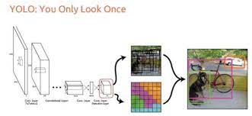

Fig:- YOLO Architecture

YOLO (You Only Look Once) is a deep neural network-based object detection system that can recognise items in pictures and videos with a single forward pass. The input picture is divided into cells using YOLO, and each cell forecasts a set of bounding boxes with a confidence score and class probabilities. YOLO employs a convolutional neural network (CNN) architecture that is trained from start to finish to improve detection accuracy.

YOLO is used in smart traffic management to recognise and track automobiles in traffic footage. To learn how to recognise and localise automobiles, the YOLO algorithm is first trained on a collection of traffic movies. YOLO then takes in a traffic video and outputs a collection of bounding boxes around the identified cars, as well as their class probabilities and confidence ratings, during inference.

**Object Detection:-**

The suggested solution's next stage is to apply object detection to the previously received frames. The incoming frames will be forwarded to the object detection model of the user's choosing in a multi-threaded environment to obtain detections of all adequately visible cars in each scene concurrently. As mentioned in the preceding section, there are two potential alternatives of well-known object detectors trained on the MS-COCO dataset to perform this object detection. Following is a full explanation of both of the chosen models. YOLO is one of many real-time object identification methods that can recognise a moving item. set of different Object classes in a given picture or video. YOLO begins by dividing pictures into smaller grids, which are then used to anticipate anchor boxes, also known as boundary boxes, surrounding the item being spotted. It accomplishes this by applying the 1x1 detection kernel on the feature map at several locations throughout the network and at multiple resolutions. The predictions are made on three distinct scales while downsampling the picture resolutions by 32, 16, and 8 factors, respectively.

**ALEXNET Architecture:-**

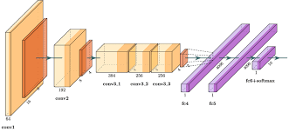

Fig:- ALEXNET Architecture

AlexNet, on the other hand, is a convolutional neural network design used for image categorization. It was one among the first deep learning architectures to obtain cutting-edge results on the ImageNet dataset of millions of labelled pictures.AlexNet is used for feature extraction in the context of smart traffic management. AlexNet is used to extract information such as vehicle type, colour, and size from observed cars after the YOLO algorithm has spotted and localised them in traffic footage. These characteristics are then employed for traffic flow analysis and sign identification.

In summary, YOLO is employed in traffic videos for object identification and tracking, while AlexNet is used for feature extraction and categorization of the observed items. These two deep learning architectures work together to form the foundation of the proposed smart traffic management system.

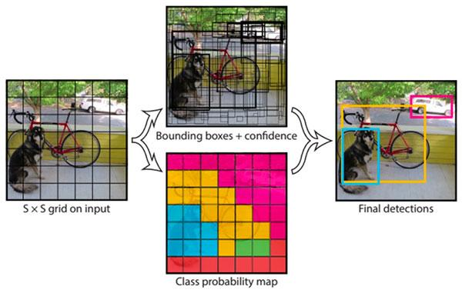

Fig:- Class Probability Map

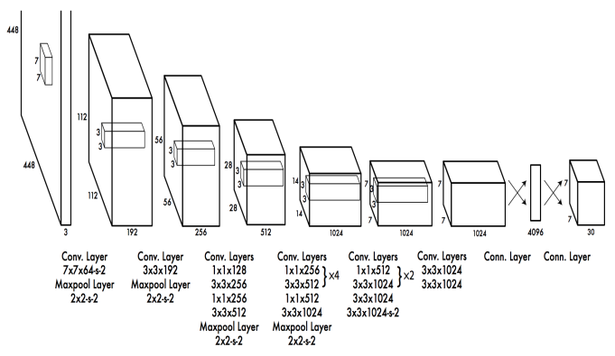

Fig:- Layers Diagram

This is the python library which is called “You Only Look Once”. It is “real time object detections recognition system”. The YOLO is a single neural network.

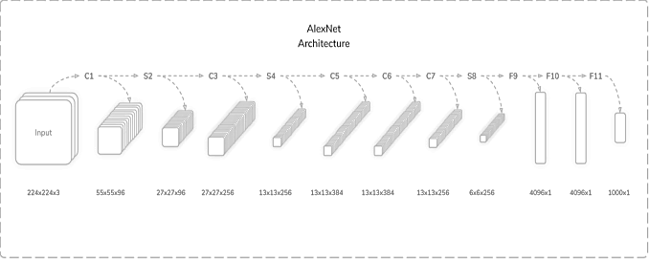

*Fig:- ALEXNET Architecture Diagram*

To stream movies, we use the AlexNet CNN Model architecture. Essentially, we are using this to distinguish different sorts of ambulances from video. We are using a dataset to teach the algorithm to determine the Ambulance for various activities. We save several sorts of vehicle images in our collection. This can assist our systems detect all of the automobiles, motorbikes, and other vehicles.Convolution.

* Convolution Layer (96, 11×11)
* Max Pooling Layer (3×3)
* Convolution Layer (256, 5×5)
* Max Pooling Layer (3×3)
* Convolution Layer (384, 3×3)
* Convolution Layer (384, 3×3)
* Convolution Layer (256, 3×3)
* Max Pooling Layer (3×3)
* Fully-Connected Layer (4096)
* Fully-Connected Layer (4096)
* Fully-Connected Layer (1000)

1. **Input to AlexNet**

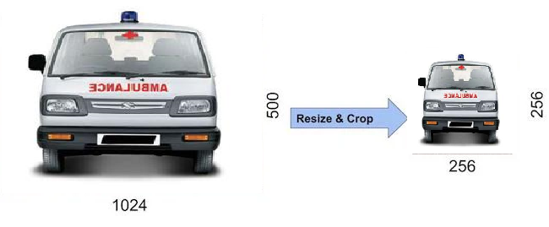

Fig:- Ambulance Detection

We're feeding the image into AlexNet; it's an RGB image. This is referred to as we are training, and all of the dataset pictures are being trained with the size 256*256.

If the input picture size is not 256*256, the image is rescaled so that it may be shorter in size and length 256, and the image is cropped from the centre sections and converted to a size of 256*256. Raw RGB pixel values are used to train the picture. As a result, if the supplied picture is grayscale, it has been transformed to RGB. Random cropping produced 257 * 257 pictures from 256 * 256 photos, which were then put into AlexNet's first level.Overlapping

Max Pooling

Max Pooling layers are often used to reduce the width and height of tensors while keeping the depth constant. Overlapping Max Pool layers are similar to Max Pool layers in that the neighbouring windows for which the maximum is determined overlap. Pooling windows of size 33 with a stride of 2 between neighbouring windows were employed by the writers. When compared to employing non-overlapping pooling windows of size 22 with a stride of 2 that would yield the same output dimensions, the overlapping nature of pooling helped cut the top-1 error rate by 0.4% and the top-5 error rate by 0.3%, respectively.

ReLU Nonlinearity

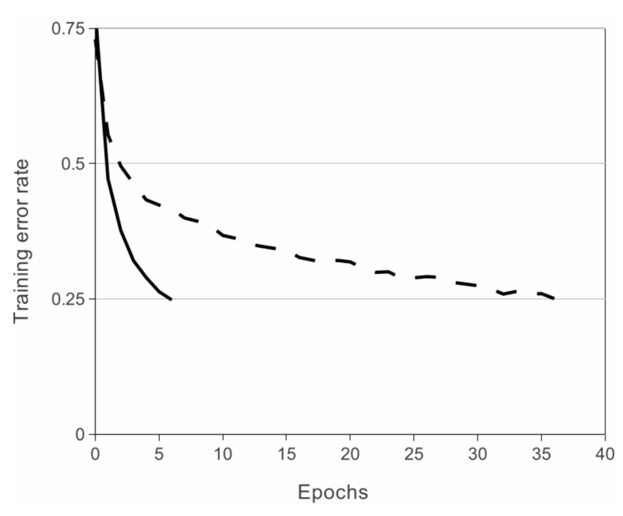

Fig:- ReLU Nonlinearity

An important feature of the AlexNet is the use of ReLU(Rectified Linear Unit) Nonlinearity. Tanh or sigmoid activation functions used to be the usual way to train a neural network model. AlexNet showed that using ReLU nonlinearity, deep CNNs could be trained much faster than using the saturating activation functions like tanh or sigmoid. The figure below from the paper shows that using ReLUs(solid curve), AlexNet could achieve a 25% training error rate six times faster than an equivalent network using tanh(dotted curve). This was tested on the CIFAR-10 dataset. Lets see why it trains faster with the ReLUs. The ReLU function is given by

f(x) = max(0,x)

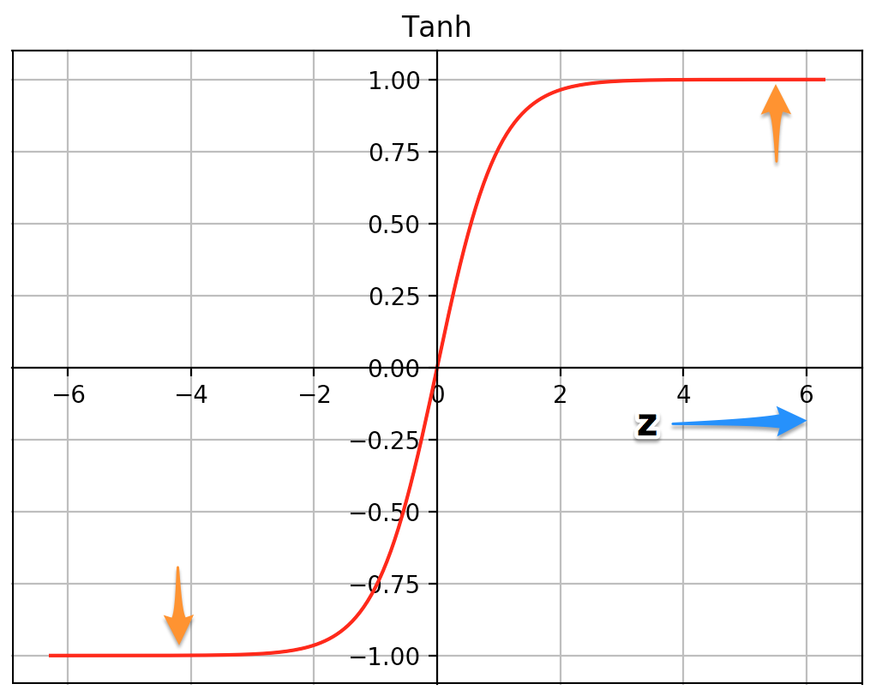

Fig:- Convocation Layer Graph 1

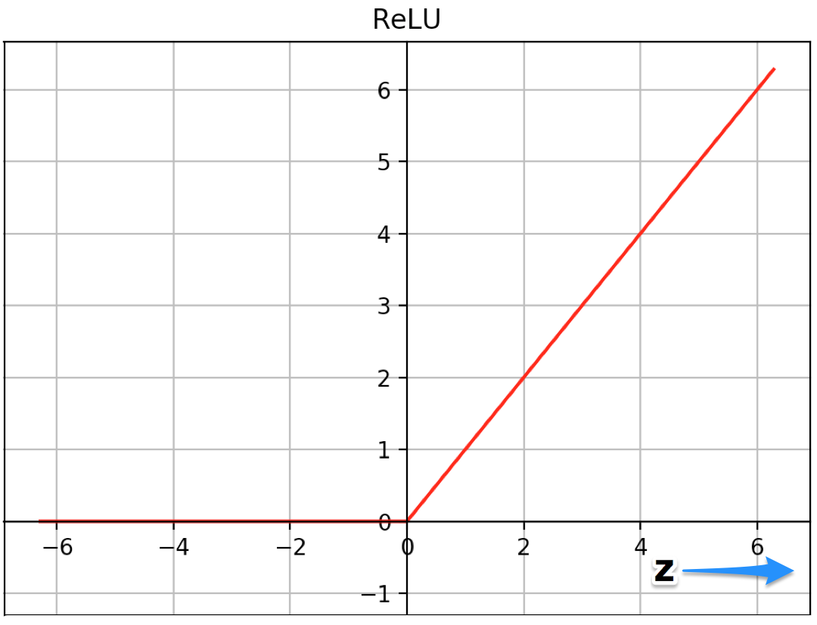

Fig:- Convocation Layer Graph 2

The plots of the two functions, tanh and ReLU, are shown above. At very high or very low z values, the tanh function saturates. The slope of the function approaches 0 in certain locations. This has the potential to slow down gradient decline. For higher positive values of z, however, the slope of the ReLU function is not near to zero. This allows the optimisation to converge more quickly. The slope remains 0 for negative z values, however the majority of neurons in a neural network normally have positive values. For the same reason, ReLU triumphs over the sigmoid function.

**Data Augmentation**

“Displaying several variations of the same image to a Neural Net helps to prevent overfitting. You're pushing it not to remember! It is frequently feasible to produce extra data for free from existing data! Here are a handful of the AlexNet team's tricks."

**Data Augmentation by Mirroring**

We have a problem with automobile reflecting images. In this case, we are training our dataset in such a way that it may be doubled in size by just flipping the image on the vertical axis. Figure 1 shows how we can train our dataset.

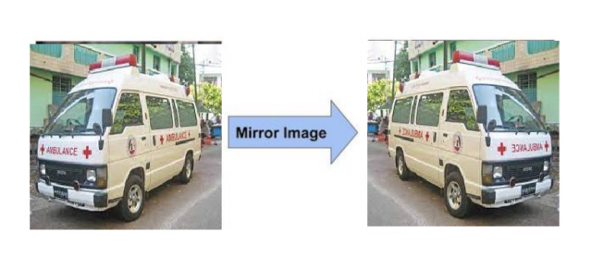

Fig: Training detection from mirror images of cars

CONVOLUTION NEURAL NETWORK

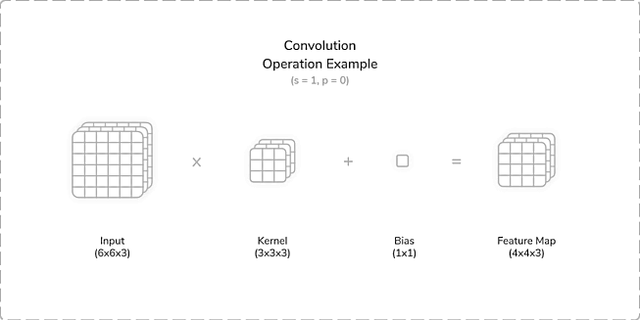

Fig: Convolution Operation Example 1

Convolutional Neural Networks were developed first to replicate the biological processes of human vision. To develop diverse network topologies, the networks used numerous layers that were organised in various ways.

The three types of layers that traditional neural networks included were:

1. Convolution Layers
2. Subsampling Layers
3. Fully Connected Layers

Two-dimensional convolution layers used trainable *kernels* or filters to perform *convolution* operations, sometimes including an optional trainable *bias* for each kernel. These convolution operations involved *moving* the kernels over the input in steps called *strides*. Generally, the larger the stride was, the more spaces the kernels skipped between each convolution. This led to less overall convolutions and more miniature output size. For each placement of a given kernel, a multiplication operation was performed between the input *section* and the kernel, with the bias summed to the result. This produced a *feature map* containing the convolved result. The feature maps were typically passed through an activation function to provide input for the subsequent layer. The size of the feature map was calculated as [(input_size − kernel_size + 2 × padding) / stride] + 1.

Subsampling Layers

To down sample input characteristics, two-dimensional subsampling layers employed non-trainable kernels or windows. This often lowered the size of the features greatly and aided in removing a network's dependency on location. There were two methods of traditional subsampling: average pooling and maximum pooling. Both approaches calculated the average or maximum value of each kernel's values to be included in the resultant feature map. The feature map size for subsampling layers was determined in the same way as it was for convolution layers. Some of these layer implementations provided trainable parameters to improve overall model learning.

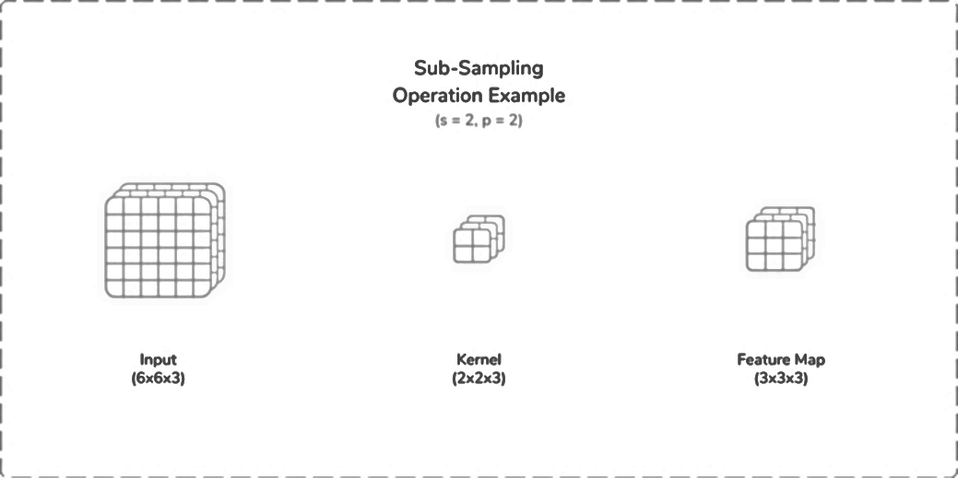

Fig: Convolution Operation Example 2

* 1. **Methodology:-**

The simulated traffic signals, which have four roads with four traffic lights each. In general, each route is given 30 seconds to clear traffic. As a result, we want to monitor each side of traffic using a camera and the assistance of machine learning. Capturing photos or live videos and processing them using necessary Python packages is YOLO. We have a variety of automobiles. One of them is the ambulance. We can't wait for the light to clear traffic. As a result, we must understand about the differences between cars for our research. The AlexNet CNN architecture is utilised to train the systems. The working steps are as follows:

* The camera sends photos to the system for processing at regular intervals.
* This may be calculated by the density of traffic on the roads, and the time of the traffic clear is altered depending on the calculations, as indicated in the result.
* The system determines which signal is open and for how long, and it activates the traffic lights.

The solution can be explained in four simple steps:

* Create a picture of each track in real time.
* Scan the area to assess the traffic density. .
* Enter this information into the time management module. The output is the needed time intervals for each track

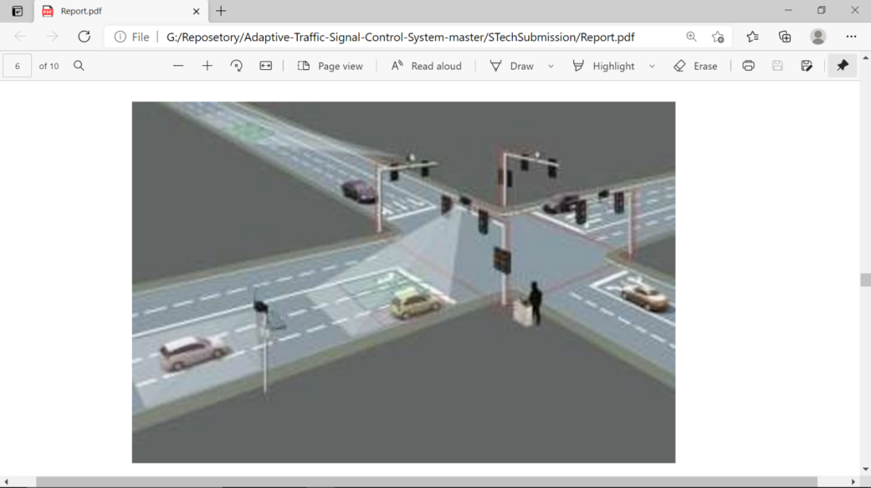

Fig:-Traffic Signal Example

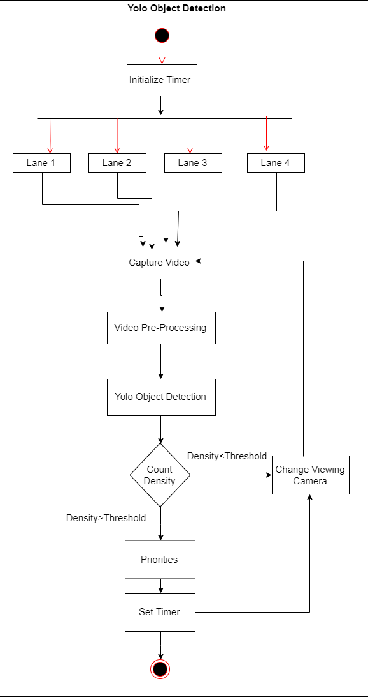

Fig:- YOLO Object detection Flow Diagram

**3.3 Details of Hardware and Software:-**

**3.2.1 Details of Hardware:-**

* Processor : i3 or above
* RAM : 12GB
* Hard Disk : 64GB
* Camera : 720p/1080p

**3.2.2 Details of Software:-**

* IDE : Visual studio, Jupyter Notebook
* FrontEnd : Python
* BackEnd : Python, Machine Learning

Chapter 4

**Experimentations and Results**

**4.1 Details of Dataset:-**

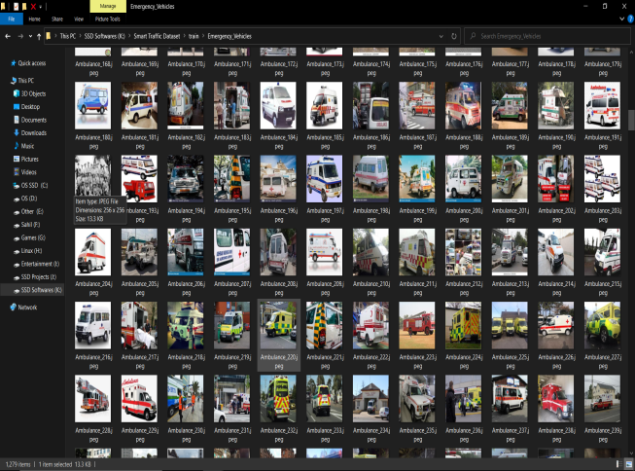Basically, the dataset that we utilised is a manually constructed dataset in which we gathered the Emergency Vehicle pictures and the Non Emergency Vehicle Dataset, which we obtained from Google. So, in this dataset, we gathered 1380 Emergency Vehicle Images and 1,496 Non-Emergency Vehicle Images, and we divided this dataset into training and testing halves during training

Fig:- Dataset 1

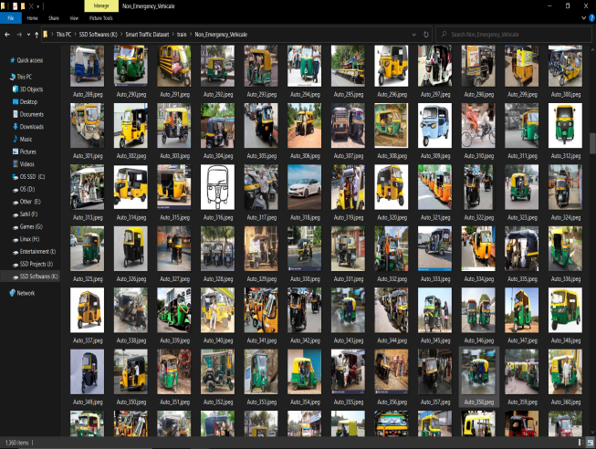

Fig:- Dataset 1

**4.2 Output:-**

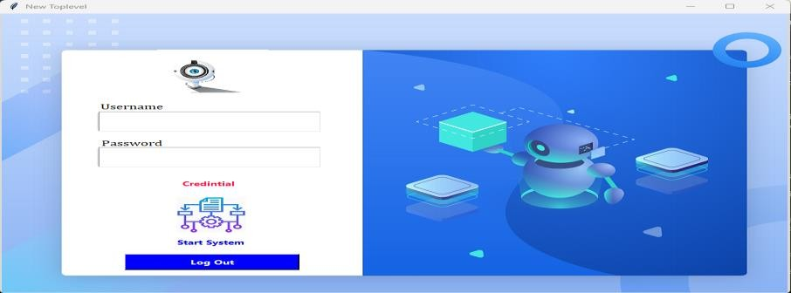Fig:- Login page

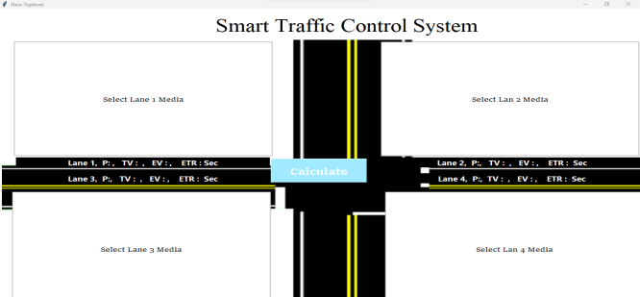

Fig:- Dashboard screen

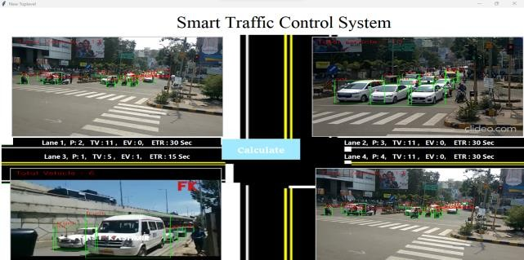

Fig:- Signal Light Control Screen

**4.3 Discussion:-**

The smart light control system based on ML, which employs the AlexNet and YOLO algorithms, has shown encouraging results in traffic management. The proposed system includes real-time traffic flow monitoring and optimisation, as well as the use of machine learning algorithms to recognise and track cars and manage traffic signals.

The method was tested on a collection of traffic videos, and the findings showed improved traffic flow and reduced congestion in congested locations. The implementation of the YOLO algorithm for vehicle identification and tracking, in conjunction with AlexNet for feature extraction, allowed for precise and efficient traffic flow analysis, resulting in optimised traffic signal control.

The system also includes a component for detecting and prioritising emergency cars, which can detect and recognise emergency vehicles in real time and modify traffic signals to give them precedence. This feature has the potential to dramatically shorten emergency response time, eventually enhancing public safety.

Furthermore, the suggested system has scalability and can be combined with other smart city technologies, such as IoT and cloud computing, to establish a comprehensive smart city ecosystem.

Overall, the smart light control system based on machine learning has shown to be beneficial in tackling traffic-related difficulties and enhancing traffic management. The system can be a great resource for traffic enforcers and researchers looking to improve urban traffic flow and safety. Further research and development may increase the system's accuracy and efficiency, making it an even more effective tool for traffic control in the future.

Chapter 5

**Testing**

|  |  |  |  |  |  |
| --- | --- | --- | --- | --- | --- |
| Test Case​ ​ID | Objective | Steps/  Description | Expected  Output | Actual  Output | Result |
| TC 1 | Input 1 frame | Select only one video | Video Upload | Video Uploaded | PASS |
| TC2 | Input another | Select only one video | Video should upload | Video Uploaded | PASS |
| TC3 | Count vehicle | Select one video | Vehicle numbers should be displayed | Vehicle numbers displays | PASS |
| TC4 | Check login page | Check username and password with right details | Login access | Login accessed | PASS |
| TC5 | Check login page | Check username and password with wrong details | Should not give access | Doesn’t give access | PASS |

Chapter 6

**Conclusion and Future Scope**

**6.1 Conclusion:-**

Finally, the suggested smart traffic management technique based on YOLO and AlexNet will enable accurate vehicle identification and tracking, efficient traffic flow analysis, and effective traffic sign recognition. Drivers will receive real-time alerts and forecasts from the system, decreasing traffic congestion and boosting road safety.

The YOLO algorithm can correctly and effectively detect and track cars, while AlexNet can extract crucial information from video such as vehicle type, colour, and size. This data may be used to forecast traffic and notify drivers of forthcoming road conditions and rules.

Overall, the suggested smart traffic management technique based on YOLO and AlexNet is a viable answer to present traffic management difficulties. However, there are several constraints, such as the lack of large-scale traffic datasets, the system's real-time performance, and the necessity for hardware optimisation for real-world implementation. As a result, more study is needed to overcome these shortcomings and improve the suggested technique.

.

**6.2 Future Scope:-**

The project's future scope includes spotting traffic accidents using camera sensors and video processing. We can develop a software system that can detect overlapping pictures in real-time video streaming and use image overlap to determine accident conditions. If there is overlap, we can utilise SMTP to deliver messages straight to government hospitals. We will enhance the accuracy in the future because the proposed algorithm is still in development. To boost performance, machine learning techniques and forecasting approaches can be used to identify observed lights. The rectangular contour of the traffic signal template may be identified using template matching with a circular light within. As the car travels over different roads, the brightness and colour values of the traffic lights in these areas vary greatly, necessitating dynamic thresholding.

Chapter 7

**Referances**

1. Liu, J., Yu, Y., & Wang, Y. (2021). Smart traffic management using YOLOv3 and K-means algorithm. In 2021 IEEE 14th International Conference on Intelligent Computation Technology and Automation (ICICTA) (pp. 312-317). IEEE.
2. Yang, L., Xu, Z., & Wu, Y. (2020). Research on traffic flow prediction based on machine learning. In 2020 3rd International Conference on Information Science and Systems (ICISS) (pp. 90-94). IEEE
3. Saini, R., & Gupta, A. (2019). Traffic signal recognition using deep learning: A review. In 2019 4th International Conference on Internet of Things: Smart Innovation and Usages (IoT-SIU) (pp. 1-5). IEEE.
4. Yolov3: An incremental improvement. (2018). Retrieved from https://arxiv.org/abs/1804.02767
5. Wang, H., Lu, H., & Yang, X. (2018). Traffic sign detection and recognition using YOLO. In 2018 International Conference on Computer, Information and Telecommunication Systems (CITS) (pp. 1-4). IEEE.
6. Reddy, A. G., & Reddy, A. R. (2018). Smart traffic management using machine learning. International Journal of Advanced Research in Computer Science, 9(1), 177-181.
7. Liu, W., Anguelov, D., Erhan, D., Szegedy, C., Reed, S., Fu, C. Y., & Berg, A. C. (2016). SSD: Single shot multibox detector. In European conference on computer vision (pp. 21-37). Springer, Cham.
8. Karpathy, A., Toderici, G., Shetty, S., Leung, T., Sukthankar, R., & Fei-Fei, L. (2014). Large-scale video classification with convolutional neural networks. In Proceedings of the IEEE conference on Computer Vision and Pattern Recognition (pp. 1725-1732).
9. Ouyang, W., & Wang, X. (2013). Joint deep learning for pedestrian detection. In Proceedings of the IEEE International Conference on Computer Vision (pp. 2056-2063).
10. Krizhevsky, A., Sutskever, I., & Hinton, G. E. (2012). Imagenet classification with deep convolutional neural networks. In Advances in neural information processing systems (pp. 1097-1105).

**Team Information**

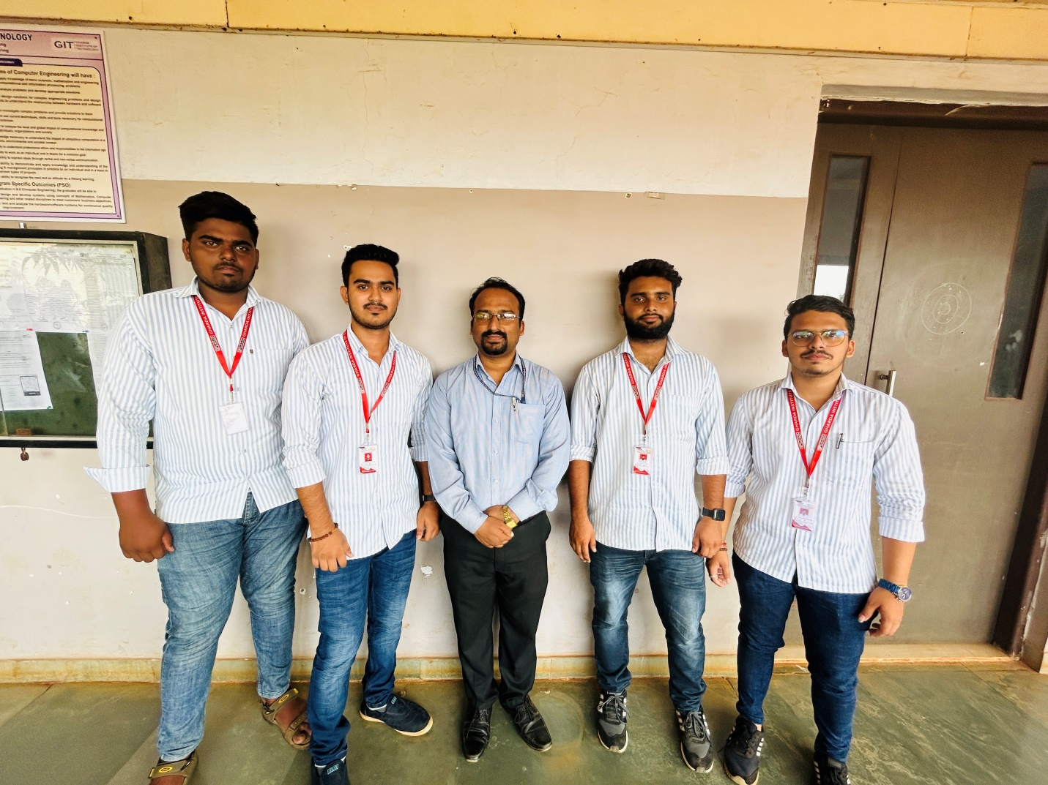

From left to right:-

* 1. Akshay Dundappa Desai (desaiakshay552@gmail.com)
  2. Sanket Prakash Gawade (sanketgawade12345@gmail.com)
  3. Adnan Khalid Khise (adnankhise2018@gmail.com)
  4. Prathmesh Rajendra Kadam ([prathmeshkadam43@gmail.com](mailto:prathmeshkadam43@gmail.com))

Project Guide: Prof. R.B.Pawar

